1. **Overview of Election Audit:** Explain the purpose of this election audit analysis.

I was tasked with assisting a board member tabulate the results of a local election in the state of Colorado. The task was to report the total number of votes combined from the three different counties along with the votes cast per candidate. Afterwards being able to have the code determine who was the winner by popular vote and the percentage of each candidate. The information will be compiled using a Python code, This way once the code is written with some small changes it can be used in future elections to help gather and analyze the data

1. **Election-Audit Results:** Using a bulleted list, address the following election outcomes. Use images or examples of your code as support where necessary.
   * How many votes were cast in this congressional election?
   * The Total amount of votes cast in this election was 369,711 and below is the code used to gather the date along with its output. Below is the code
   * 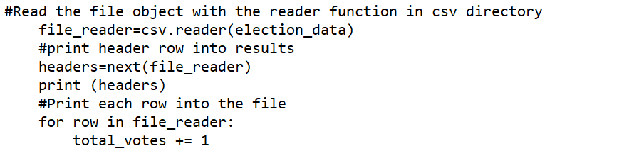
   * The code is iterating through the csv file, the data provided, and adding a count each time it goes through a unique row. The original value for the int total_votes was set equal to zero and there were 369,711 rows returning the exact number of total votes.
   * Provide a breakdown of the number of votes and the percentage of total votes for each county in the precinct.
   * There were 3 counties that were being observed I will list them in ascending order based on votes and percentage of total. Arapahoe had 6.7% of the total votes at 24,801, while Jefferson was counted with 10.5% of the total vote at 38,555. Finally, the county with the highest turn out was Denver with 82.8% of the total vote coming to 306,055 votes.
   * Which county had the largest number of votes?
   * Given the math and comparing it to the other counties Denver had the largest number of votes. As you can see out in the image below highest number of votes by count and percentage was Denver. I had the code print out the results that can be analyzed by comparing the percentages and distinctly had the highest turnout printed to the (.txt) page.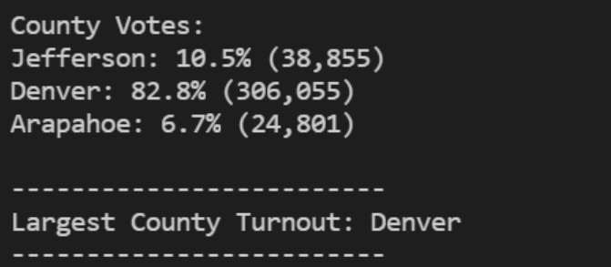
   * Below I have attached an image of the code that prints off the results for county votes, their percentages, and the name of the county. The code is already running through a list and just recreating the votes as they are associated with the county name then the second line of code is using the operation of votes/total x 100 to give the percentage.
   * 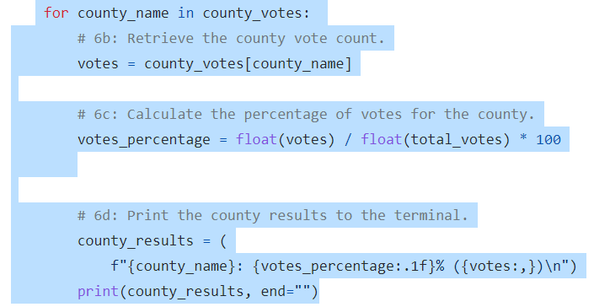Provide a breakdown of the number of votes and the percentage of the total votes each candidate received.
   * The same way I gathered the information from the csv about counties is how I went about finding the information for the candidates. In order from least to greatest votes received Raymon Anthony Doane (3.1%) 11,606, Charles Casper Stockham (23%) 85,213, and finally Dian DeGette (73.8%) 272,892 votes.
   * 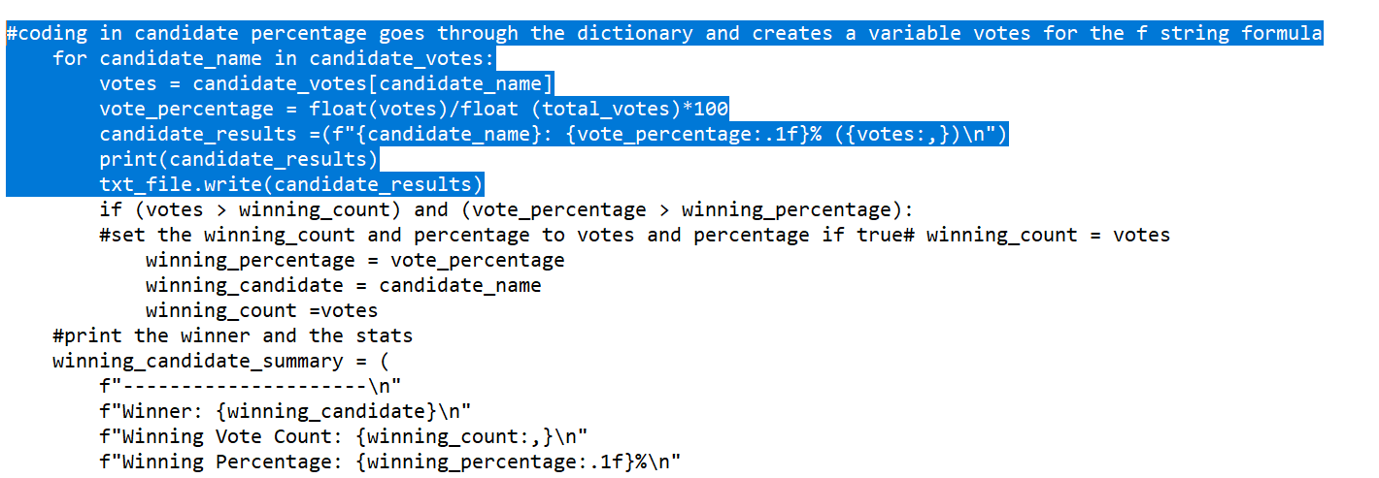
   * Which candidate won the election, what was their vote count, and what was their percentage of the total votes?
   * The above code and states to the election analysis.txt file that the “Winner” is Diana DeGette who had a vote count of 272,892 votes which ended up being 73.8% of the total votes.
2. **Election-Audit Summary:** In a summary statement, provide a business proposal to the election commission on how this script can be used—with some modifications—for any election. Give at least two examples of how this script can be modified to be used for other elections.

**This script does not have to be modified as long as the information is presented in the same format as was given.** You can even increase the number of counties or candidates. Since we are checking for any unique names not counting to a capacity. Meaning that even 100% of the votes can be for a different county or candidate and the code would be able to compile the data.

Now the drawbacks are that the data has to be presented the same way as stated earlier. Any variations to the presented data would result in the code having to be modified to locate the name of the candidate or county if it is on a different column.

Another drawback to the set up is if votes are being squeezed onto the same row. **For instance, if Row 391 was representing how a family voted so that row is counting 2 votes in the data.** The issue with the code is that it would only tally that as one vote. This could lead to different results that the actual.

If you are trying to add this code to a list of votes that have already been tallied, you just need to change the starting value from 0 to the amount that was counted before. This way you can use this data multiple times and compile the data on top of each other.

As well as wanting to check who got the lowest vote count and percentage you just need to adjust the if loop

(if votes> winning_count) to not look for the greatest value but the less than by switching to the less than symbol. You would have to add in lines to make sure you are not crashing the code. It could return the second lowest vote count. You would have to add in and line to make sure you are getting lower than 1st place and lower than 2nd place.